Helicopter Operations Safety

Scope.
These orders shall establish minimum safety standards for the use of helicopters. These orders do not supersede any of the regulations administered by the F.A.A., the State Division of Aeronautics, and City or County entities.

Helicopters and Helicopter Cranes shall be expected to comply with any applicable regulations of the F.A.A.

General Requirements.
- Prior to the start of any operation involving the use of a helicopter, a thorough survey of the conditions and hazards on the job site shall be made by the employer in conjunction with the pilot or pilot's representative to ensure a safe operation.

- A Code of Safe Practices shall be formulated and enforced for operations involving the use of a helicopter. This code shall include, but is not limited to, the safe practices presented in Appendix Plate C-36-a.

- A daily briefing shall be conducted prior to starting work to set forth the plan of operation for that day. This briefing shall include planning to minimize possible hazards of the day's operation and all personnel exposed shall be informed and directed as to safeguards and escape procedures.

- If the helicopter pilot in command for any reason believes that a lift or operation cannot be performed safely, then that lift or operation shall not be attempted.

- Helicopter operations shall not be performed beyond the helicopter's approved external load capacity or pilot's certification. The pilot's employer shall ascertain before operations begin that the pilot is properly certificated by the F.A.A. and qualified to perform the planned operations.

- Slings and tag lines. Load shall be properly slung. Tag lines shall be of a length that will not permit their being drawn up into rotors. Pressed sleeve, swedged eyes, or equivalent means shall be used for all freely suspended loads to prevent hand splices from spinning open or cable clamps from loosening.

- Cargo hooks. All electrically operated cargo hooks shall have the electrical activating device so designed and installed as to prevent inadvertent operation. In addition, these cargo hooks shall be equipped with an emergency mechanical control for releasing the load. The hooks shall be tested prior to each day's operation to determine that the release functions properly, both electrically and mechanically.

- Personal protective equipment – when working with Power Transmission and Distribution or when a helicopter is used to lift, move or hoist objects:

Personal protective equipment for employees receiving the load shall consist of complete eye protection and hard hats secured by chinstraps.
Loose-fitting clothing likely to flap in the downwash, and thus be snagged on hoist line, shall not be worn.
Loose gear and objects. Every practical precaution shall be taken to provide for the protection of the employees from flying objects in the rotor downwash. All loose gear within 100 feet of the place of lifting the load, depositing the load, and all other areas susceptible to rotor downwash shall be secured or removed.

- Housekeeping. Good housekeeping shall be maintained in all helicopter loading and unloading areas.

- Operator responsibility. The helicopter operator shall be responsible for size, weight, and manner in which loads are connected to the helicopter. If, for any reason, the helicopter operator believes the lift cannot be made safely, the lift shall not be made.

- Hooking and unhooking loads. When employees are required to perform work under hovering craft, a safe means of access shall be provided for employees to reach the hoist line hook and engage or disengage cargo slings. Employees shall not perform work under hovering craft except when necessary to hook or unhook loads.

Landing Operations.
- Landing and hovering sites shall be chosen with approval of the pilot or pilot's representative.

- All such sites shall have at least a 200-foot diameter area clear of all loose materials and objects which could be hazardous if displaced by rotor downwash. The helicopter shall be required to deposit or lift loads in the center of the approved area.

- Precautions shall be taken by the employer to eliminate as far as practical reduced visibility.

- Access and egress to the helicopter shall be from the front and along the same level or to a level lower than the helicopter. No one shall be permitted to approach or leave the helicopter while the engine is running or the rotor is turning without a permissive signal or instruction from the pilot or pilot's designee.

- Built-up landing sites shall be capable of supporting a helicopter on any single square foot of the landing surface and provide good footing.

- Prepared landing sites on hillsides shall be no less than 12 feet by 12 feet and shall be large enough to land the helicopter so that the largest rotor clears the hillside by a distance equal to its radius measured horizontally from the tip of the rotor.

NOTE: Except in emergency.

Static Electricity.
An effective method of protecting workers from static electrical discharge shall be provided.

NOTE: See Appendix for a recommended method.

Static charge when lifting, moving or hoisting a load. Static charge on the suspended load shall be dissipated with a grounding device before ground personnel touch the suspended load, or protective rubber gloves shall be worn by all ground personnel touching the suspended load.

Fueling.
- The engines and radio transmitters shall be shut off, and smoking, open flame or other source of ignition shall not be permitted within 50 feet of fueling operations or fuel storage areas.

NOTE: Except for F.A.A. approved alternate fueling methods or closed circuit hot refueling.

- The helicopter and fuel supply shall be securely bonded and grounded before and during fueling operations for static electrical discharge.

- There shall be two 60B:C rated fire extinguishers or equivalent fire fighting protection at each fueling station attended by ground crews.

Communications.
- During helicopter operations, the pilot shall be notified at least 30 minutes prior to any blasting operation on the project and also after each blast to signify the all-clear condition.

- The pilot shall be informed by the person in charge of the project of the erection of any newly suspended line or other navigational hazard on the project or in the area of helicopter operations.

- Signal systems between air crew and ground personnel shall be understood and checked in advance of hoisting the load. Hand signals shall be as shown in Plate C-36-c Appendix.

- The pilot shall receive signals from only one signal person who is distinguishable from the rest of the crew.

- There shall be constant reliable communication between the pilot, and a designated employee of the ground crew who acts as a signalman during the period of loading and unloading. This signalman shall be distinctly recognizable from other ground personnel.

Ground Crew.
- All ground crewmembers shall be thoroughly instructed by the pilot or pilot's representative in their duties and of the immediate hazards. Escape procedures shall be planned with the pilot or pilot's representative in event of helicopter failure.

- Ground crewmembers shall wear dust goggles for eye protection and approved head protection with chin straps in place. Ear protection and dust protection where required shall be in accordance with applicable safety orders.

- Only those persons associated with the helicopter operations shall be permitted to approach within 50 feet of the operating helicopter.

Cargo Loading and Handling.
- All cargo shall be loaded and secured under the direction of the pilot or pilot's designee.

- No passenger shall be transported in the helicopter with a sling load and no person shall be transported as an external or sling load, except in an emergency.

EXCEPTION: Unless authorized by the F.A.A.

- Explosives and other "dangerous materials" shall not be transported except as authorized by F.A.A.

- All sling loads, including line stringing devices, shall be attached only to quick release devices. Steel or metallic sling ends shall be of the pressed sleeve or swedged eye-type, or equivalent. Tag lines shall be of a length or secured in such a manner that will not allow their being drawn up into the rotors.

- Automatic release devices are prohibited in all construction operations where ground crews are used. The devices shall be activated only for actual placement of loads. Electrical release devices shall have mechanical back-up, be checked each day of operation, and be designed to prevent inadvertent operation.

- When stringing conductive lines or conductors, there shall be radio communication between the helicopter and the ground crew.

- When stringing lines or conductors close to or parallel to energized lines, conductive lines or reels, pay-out machines, and conductors shall be grounded as required by the High Voltage Electrical Safety Orders. Hoist wires or other gear shall not be attached to any fixed ground structure.

EXCEPTION: When pulling lines or conductors that are allowed to "pay-out" from a container or roll off a reel.

- External sling load operations shall not be performed if electrical storms in the immediate vicinity make the work unsafe.

- Load landing operations shall not be performed when the wind conditions are deemed too unsafe by the pilot or ground crew.

- There shall be a minimum clearance of at least 25 feet between any energized power line, rated 50 KV or below, and any part of the rotorcraft load combination. This clearance requirement shall increase at the rate of 1/2 inch for each 1 KV.

EXCEPTION: These minimum clearances shall not apply to helicopters or their external loads specifically utilized for power line construction, maintenance, and repair where the work in progress is under the direct supervision of the utility.

Exposed Locations.
- While working at the edge of or on a steep slope, members of ground crews shall be protected from falling by:
- A barrier of adequate design to restrain a falling person or;
- A safety belt with a quick-release buckle and a life line at least 50 feet long.

- Where practicable when using safety belts, the area shall be cleared of objects which might snag the life lines in an escape procedure. (See Plate C-36-b, Appendix.)

- Workers receiving materials while on a tower-type structure shall not be positioned in a place of unnecessary exposure and shall be secured to the structure by safety belts or other equivalent protection.

- Ground crews on elevated surfaces more than 7 1/2 feet high shall be protected against being swept off by rotor downwash. (See Plate C-36-b, Appendix.)

APPENDIX PLATE C-36-a SAFE PRACTICES--HELICOPTERS
1. Do not approach or leave a helicopter while its engines are running unless in a crouched position and the pilot or pilot's designee signals that it is safe to do so.

2. Always approach and leave the helicopter in plain view of the pilot or as directed by the pilot's designee; never from the rear.

3. Approach and leave the helicopter on a level with the craft or a lower level, never from or to higher ground than that of the helicopter.

4. Wear goggles and head protection with chin strap under the chin when in the vicinity of an operating helicopter. Loose-fitting clothing likely to flap in the downwash and possibly be snagged on the hoist line shall not be worn.

5. Load all cargo and secure it to the satisfaction of the pilot or pilot's designee.

6. Do not put tag lines on sling loads without the pilot's or pilot's designee's permission and limit their numbers, their placement, and their lengths to the pilot's satisfaction.

7. Do not place explosives, flammables, or other dangerous materials on board any aircraft without the pilot's knowledge.

8. Carry all materials to or from the helicopter in a horizontal position not above waist level.

9. Do not smoke within 50 feet of a helicopter, fuel storage, or fueling operation.
10. Do not stand directly under a hovering helicopter longer than necessary to hook-up or unhook the load.

11. Always watch the helicopter, sling load, hook, or bottom end of the cable to avoid being hit.

12. Know the escape procedure at each operation site.

13. Keep landing and hovering areas clear of loose and lightweight materials.

14. Notify the person in charge of the project when erecting a suspended line, tower or other navigational hazard.

15. Turn off radio transmitter when in vicinity of explosives or explosive loading operations.

16. Passengers transported by helicopter shall be instructed to:
- Board and depart only on instruction from the pilot.
- Use seat belts during takeoff, flight, and landing.
- Do not talk unnecessarily to the pilot.
- Remain seated during the time you are aboard.
- Watch for other airborne aircraft and navigational hazards and call them to the attention of the pilot.
- Do not smoke unless permitted by the pilot.

17. When performing as a crew member in external operations, listen to and be familiar with the normal sounds emitted by the helicopter in flight so that you will have the earliest notice of trouble and can avoid dangerous exposure.

18. When visibility is reduced by dust or other conditions, ground personnel shall exercise special caution to keep clear of main and stabilizing rotors.

PLATE C-36-b

TEMPORARY HELICOPTER LANDING SITE (Elevated)

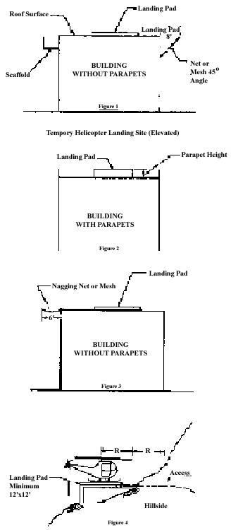

PLATE C-36-b GROUND CREW PROTECTION ON SLOPES

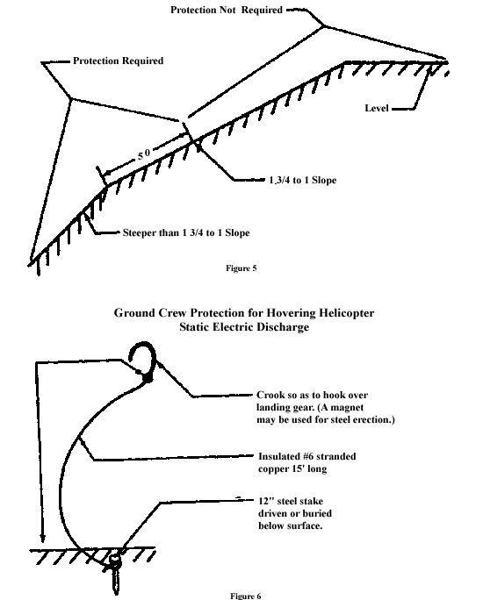

PLATE C-36-c HELICOPTER HAND SIGNALS
Signal systems. Signal systems between aircrew and ground personnel shall be understood and checked in advance of hoisting the load. This applies to either radio or hand signal systems.

FIGURE N-1 - HELICOPTER HAND SIGNAL

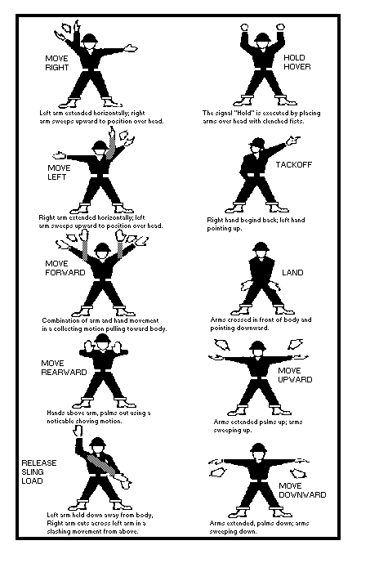

Weight limitation.
The weight of an external load shall not exceed the manufacturer's rating.

Ground lines.
Hoist wires or other gear, except for pulling lines or conductors that are allowed to "pay out" from a container or roll off a reel, shall not be attached to any fixed ground structure, or allowed to foul on any fixed structure.

Visibility.
When visibility is reduced by dust or other conditions, ground personnel shall exercise special caution to keep clear of main and stabilizing rotors. Precautions shall also be taken by the employer to eliminate as far as practical reduced visibility.

Approach distance.
No unauthorized person shall be allowed to approach within 50 feet of the helicopter when the rotor blades are turning.

Approaching helicopter.
Whenever approaching or leaving a helicopter with blades rotating, all employees shall remain in full view of the pilot and keep in a crouched position. Employees shall avoid the area from the cockpit or cabin rearward unless authorized by the helicopter operator to work there.

Personnel.
Sufficient ground personnel shall be provided when required for safe helicopter loading and unloading operations.

Fires.
Open fires shall not be permitted in an area that could result in such fires being spread by the rotor downwash.

