Radiation: Non-Ionizing

Non-Ionizing Radiation
This chapter is written from CFR 1910.97 as well as [State] state requirements.

Electromagnetic radiation.
The term "electromagnetic radiation" is restricted to that portion of the spectrum commonly defined as the radio frequency region, which for the purpose of this specification shall include the microwave frequency region.

Definitions.
Definitions applicable to this paragraph.

Partial body irradiation.

Pertains to the case in which part of the body is exposed to the incident electromagnetic energy.

Radiation protection guide.

Radiation level which should not be exceeded without careful consideration of the reasons for doing so.

Symbol.

The word "symbol" as used in this specification refers to the overall design, shape, and coloring of the rf radiation sign shown in figure G-11.

Whole body irradiation.

Pertains to the case in which the entire body is exposed to the incident electromagnetic energy or in which the cross section of the body is smaller than the cross section of the incident radiation beam.

Radiation protection guide.

For normal environmental conditions and for incident electromagnetic energy of frequencies from 10 MHz to 100 GHz, the radiation protection guide is 10 mW/cm.(2) (milliwatt per square centimeter) as averaged over any possible 0.1-hour period. This means the following:

Power density: 10 mW./cm.(2) for periods of 0.1-hour or more.
Energy density: 1 mW.-hr./cm.(2) (milliwatt hour per square centimeter) during any 0.1-hour period.

This guide applies whether the radiation is continuous or intermittent.

These formulated recommendations pertain to both whole body irradiation and partial body irradiation. Partial body irradiation must be included since it has been shown that some parts of the human body (e.g., eyes, testicles) may be harmed if exposed to incident radiation levels significantly in excess of the recommended levels.

Warning symbol.

The warning symbol for radio frequency radiation hazards shall consist of a red isosceles triangle above an inverted black isosceles triangle, separated and outlined by an aluminum color border. The words "Warning - Radio-Frequency Radiation Hazard" shall appear in the upper triangle. See figure G-11 at the end of this chapter.

American National Standard Safety Color Code for Marking Physical Hazards and the Identification of Certain Equipment, Z53.1-1953 which is incorporated by reference as specified in Sec. 1910.6, shall be used for color specification. All lettering and the border shall be of aluminum color.

The referenced Section above 1910.6 states the following:
1910.6(e)(63)
ANSI Z53.1-67 Safety Color Code for Marking Physical Hazards and the Identification of Certain Equipment, IBR approved for §§1910.97(a)(3)(ii); 1910.145(d)(2), (4), and (6).

The inclusion and choice of warning information or precautionary instructions is at the discretion of the user. If such information is included it shall appear in the lower triangle of the warning symbol.

FIGURE G-11
RADIO-FREQUENCY RADIATION HAZARD WARNING SYMBOL

Scope.

This section applies to all radiations originating from radio stations, radar equipment, and other possible sources of electromagnetic radiation such as used for communication, radio navigation, and industrial and scientific purposes. This section does not apply to the deliberate exposure of patients by, or under the direction of, practitioners of the healing arts.

RADIO-FREQUENCY RADIATION HAZARD WARNING SYMBOL
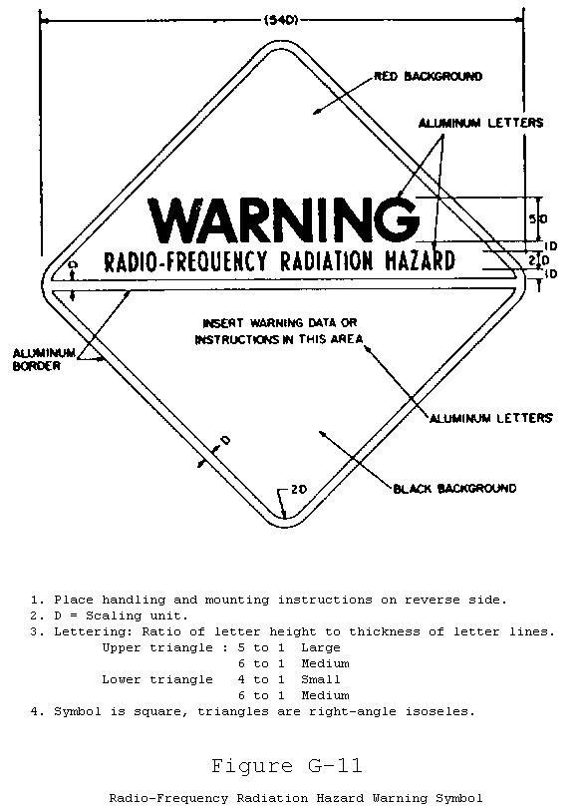

Radiofrequency and Microwave Radiation.

Definitions.

Radiofrequency (RF) Energy. Electromagnetic energy restricted to that portion of the spectrum commonly defined as the radiofrequency or RF region with frequencies between 3 megahertz (MHz) and 300 Gigahertz (GHz) and which for the purposes of this specification shall include the microwave region with frequencies between 100 MHz and 300 GHz. (Hertz = 1 cycle/second, MHz = 1 million hertz, GHz = 1 billion hertz.)

Exposure. Irradiation of any part of the body by incident RF energy.

Exposure Limits.

Employees shall not be exposed to RF energy from continuous wave or repetitively pulsed sources exceeding any of the following limits as averaged over any possible six minute (0.1 hour) period.

(1) Continuous exposure to an average maximum power density of 10 mW/cm2 (milliwatts per square centimeter) or the equivalent free space average electric and magnetic field strengths of 200 V/M (volts per meter) rms and 0.5 A/M (amperes per meter) rms respectively.

(2) Exposure to interrupted or modulated RF energy shall not exceed:

(A) An average maximum energy density of 1 mW hr/cm2 (milliwatt-hour per square centimeter);

(B) A mean squared electric field strength of 4x104 (V/M)2 (volts squared per meter squared);

(C) A mean squared magnetic field strength of 0.25 (A/M)2 (amperes squared per meter squared).

These energy densities and field strengths are approximately equivalent to a far field power density of 10 mW/cm2.

Information and Warning Signs.

In areas where employee exposure may exceed the limits specified in part (b) of this section, companies shall provide warning signs containing the following information in the following manner:
(1) Warning signs of RF radiation hazards, as described in ANSI C95.2-1966"Radiofrequency Radiation Hazard Warning Symbol," containing the necessary information and description of required protective actions. (See Figure under section 4 of this chapter.)

(2) Signs shall be posted at all entrances to accessible areas containing RF radiation levels in excess of the exposure limits described in part (b).

(3) Warning signs shall be legible at a distance of ten (10) meters.

Non-Ionizing Radiation Requirements
(a) Only qualified and trained employees shall be assigned to install, adjust, and operate laser equipment.
(b) Proof of qualification of the laser equipment operator shall be available and in possession of operator at all times.
(c) Employees, when working in areas in which a potential exposure to direct or reflected laser light greater than 0.005 watt (5 milliwatts) exists, shall be provided with anti-laser eye protection devices as specified in Section 1516(e).
(d) Areas in which lasers are used shall be posted with laser warning signs and labels in accordance with American National Standards Institute (ANSI) Z136.1-1993, American National Standard for Safe Use of Lasers, Sections 4.7-4.9, which is hereby incorporated by reference.
(e) Beam shutters or caps shall be utilized, or the laser turned off, when laser transmission is not actually required. When the laser is left unattended for a substantial period of time, such as during lunch hour, overnight, or at change of shifts, the laser shall be turned off.
(f) Only mechanical or electronic means shall be used as a detector for guiding the internal alignment of the laser.
(g) The laser beam shall not be directed at employees.
(h) When it is raining or snowing, or when there is dust or fog in the air, the operation of laser systems shall be prohibited where practicable; in any event, employees shall be kept out of range of the area of source and target during such weather conditions.
(i) Laser equipment shall bear a label to indicate maximum output.
(j) Employees shall not be exposed to light intensities above:

(1) Direct staring: 1 micro-watt per square centimeter;

(2) Incidental observing: 1 milliwatt per square centimeter;

(3) Diffused reflected light: 2 1/2 watts per square centimeter.
(k) Employees shall not be exposed to microwave power densities in excess of 10 milliwatts per square centimeter.

Ultra-Violet Radiation.
Sterilizing lamps or other equipment producing ultra-violet radiation shall be so arranged or shielded that ultra-violet radiation, either direct or reflected, does not strike employees' eyes in harmful intensity; where such arrangement or shielding is not practicable, employees shall be provided with goggles of a type which will prevent such radiation from injuring the eyes.

Areas, rooms or locations where equipment producing such radiation is located shall be posted with warning signs or legends.

