Safe Use of Drywall & Plasterers’ Stilts

Drywall Stilts
Befor stilts are used, check to make sure that OSHA does not prohibit the use of “Stilts” in your area or state.

Introduction
This guidance provides health and safety information for the employers and workers using stilts at the construction worlplaces. As a substitution for the conventional scaffolding and long ladder, the Stilts is applied in work high above the ground in indoor&outdoor decoration as well as installation and opening repairs, including suspended ceiling construction, ceiling circuit arrangement, fruit plucking, branches trimming and insects eliminating, etc.Stepping on the Stilts, the operator can walk, stand and work freely at ease indoor or outdoor while no assistant personnel and other facilities are needed, the work efficiency, consequently, is remarkably enhanced. The newly-developed Stilts is designated to imitate the movement features of the lower part of human body in line with the principle of human body bionics, which enables you feel like walking at ease with your own feet on the ground without any inconvenience at all, and offers a higher and broader space within your reach. It’s easy usage, convenient operation, innovative design and nice appearance.

Requirements
[Company_Name] wants to ensure the health and safety of its workers, as best as is reasonably practicable. Before using stilts, identify, assess and control the risks relating to the work area layout, work area condition, the work activity to be undertaken and the tools and equipment that will be used. Once this is completed, then develop, through worker consultation, safe work procedures. Implement and monitor the risk controls and, in particular, ensure that only a competent person uses stilts.

Risks When Using Stilts
The use of stilts by plasterers to gain access to ceilings, high walls and other areas poses the following risks.

- Losing one’s balance and falling to the ground through, for example, a window or over handrails, which are usually only a metre high.
- Tripping over debris, materials or tools on the floor, or falling on slippery surfaces.
- Falling over while entering a different level or going through doorways.
- Manual handling injuries caused by bending over or twisting from the stilts.

Actions Required

Work area layout
Identify all potential stilts hazards such as: changes in the level or slope of the work area; guardrails that are next to edges, walls, doors or ceiling features (eg arches, lights, bulkheads), which may restrict movement when using stilts; floor penetrations, stairwells, voids, windows and in-built furniture.

Work area condition
Do not use stilts:
- Where the ceiling height is greater than three metres.
- For walking on stairs and walking backwards.
- Until the work area is ‘plaster ready’, which means:
  - Floor surfaces are solid, level and can support stilt work activity (eg earthen floors have been concreted). Do not use on a non-floor surface (such as tables, trestles, etc).

- Floor surfaces have been cleared, swept and dry. Stilt workers need to move freely and without stepping over or moving around trip hazards, such as leads to work lights, hoses, packaging or dropped items (nails, screws, etc).

- Plumbing and electrical work has been roughed in with switch positions and access points marked and lighting cables secured.

- Floor penetrations, stairwells and voids are covered or guarded in such a way that they can be clearly seen by stilt workers. (Note: guardrails effective at normal working heights are unlikely to be effective for stilt workers, especially if the work is being done near a balcony or stairs.)

- Furniture is removed and in-built furniture, such as kitchen cupboards or architectural features, is isolated or highlighted. Do not step into or over baths or other obstructions.

Work activity
Do not commence work before risk control measures ensure that:
- Stilts are only to be used for light duty tasks such as the placing of insulation batts, installing furring channels, screwing sheets to furring channels, installing trusses and the undersides of floor joists and walls, patching, touching up and the stopping of joints using a trowel, fixing cornices and minor hand sanding. Only portable hand held tools (without leads) such as a trowel, hammer, sanding block and cordless screw gun are to be used by stilt workers.

- There is a safe means of attaching and removing stilts readily available. A rigid platform should be used for mounting /dismounting stilts with the platform at a height equal to or greater than the height of the stilts. Stepladders are not to be used for mounting/dismounting stilts. Stepping up and balancing on one stilt then bending to fit the second is also not acceptable.

- All equipment and materials required by a stilt worker should be supported by a purpose-built stand (mobile or stationary) that enables the stilt worker to access them without over-reaching or bending down below knee level. The height of the stand should be appropriate for the task being performed. Alternatively, tools and materials can be passed up to the stilt worker by another person standing on the floor. Do not pick up items from below knee level.

- The stilt worker’s torso should be vertical whenever possible, so tasks that require frequent bending should be avoided. Also do not jump with the stilts.

- The handling of long, heavy or cumbersome objects or items, such as decorative cornices and the lifting or supporting of plaster sheets should be avoided.

- Other workers cannot affect the immediate work area being used by stilt workers, unless they are working as support for the stilt worker. (If this cannot be guaranteed, the work area should be taped off or barricaded to prevent access.)

- Any waste produced and material dropped by stilt workers is promptly cleared away (by an assistant) from the floor surface they are working on.

- Emergency procedures detail how stilt workers are to evacuate.

- Supervisors should regularly check that stilt workers are not experiencing fatigue. If stilt workers begin to experience fatigue, they should immediately remove their stilts.
  - Any one period of working on stilts should be not greater than two hours. Any further sessions should be separated by at least thirty minutes of non-stilt tasks. Stilts should not be used by any individual for more than six hours per day.

- The springs are not fully compressed (caused when lifting heavy objects or exerting high upward force, such as drilling through overhead structures).

Maintenance rules of tools and equipment
Only proprietary stilts can be used. Do not use any stilts that are not from a reputable manufacturer. Follow manufacturer’s recommendations for maintenance and inspections.
- All tools and equipment including stilt and their components must be examined regularly and any worn or damaged components replaced immediately. They also must be stored, serviced and maintained by a competent person as per the manufacturer’s specifications.
- A competent person must inspect the stilts before each use. If defects are detected, repair it as per the manufacturer’s instructions before further use or, if this is not possible, destroy it to prevent further use.

Competency of workers

Workers must be competent. Stilts must not be used without proper training and workers must have experience in their use. Manufacturer’s instructions on their correct use must be followed at all times.

Trainees should be made aware of:
- How the foot and ankle action changes when wearing stilts.
- Training should also include information on:
  - work environment hazards
  - how to correctly adjust stilts so as to reduce fatigue and poor posture
  - the injuries that can occur from their unsafe use.

The stilt worker should gain experience and confidence before working and also before undertaking work activities such as working with their head up, using tools in both hands or working at maximum height.

Suitability of worksite for stilt use – supervisor checklist
2
Completed by: Date:
Location:
Activity/task:

Checking that the site is ‘plaster ready’ | ☑
Floor surfaces are solid and level (eg concreted or lined).
Floor surfaces are cleared, swept and dry.
Lighting cables (from ceilings and walls) are secured.
Electric leads – including those to working lights – are clear of the work area.
Voids (eg stairwells) and windows that may be hazardous are guarded for stilt work.
Floor penetrations (eg pipes) covered and/or highlighted.
Plastering works are the only works underway in the immediate work area.
Any other workers (besides workers assisting the stilt worker in their task) are excluded from the work areas by barricading/taping off.

Suitability of worksite for stilt use – supervisor checklist
Checking that the task is suitable for stilts | ☑
The tasks to be completed are light duty tasks.
The task can be completed without the stilt worker bending down below knee level.
The task can be completed without the stilt worker overreaching sideways.
Equipment and materials are accessible to the stilt worker without bending down or overreaching.
The task on stilts will take less than two hours (or the task can be broken into two hour blocks) with no more than six hours wearing stilts per day.
Ceiling heights are no greater than three metres.
The proposed activity and movement is permitted by the manufacturer’s instruction manual.
Tools to be used while on stilts are appropriate and compatible.

Preparation | ☑
Identification of hazardous manual handling has been completed.
Manual handling risk controls implemented.
Safe operating procedure has been completed.
Stilt workers are competent and have received training in the correct use of stilts.
The stilts are supplied from a recognised industry supplier, have been visually checked prior to mounting, are in good condition and have been maintained in accordance with the supplier’s instructions.
Stilt workers are not tired and are physically capable of performing the assigned task.
There is a suitable, rigid mounting/dismounting platform (a step ladder is unsuitable).
Emergency evacuation procedures consider stilt workers.

Steps have been taken for waste material produced during the plastering process to be promptly cleared away.

Stilt Use: Assembly & Instructions
Important
Please Read This Section Before Adjustments or Use
ATTENTION! READ THIS!

PLEASE ENSURE ASSEMBLY, INSPECTION AND MAINTENANCE IS CARRIED OUT PROPERLY.
THIS IS CRUCIAL TO YOUR PRODUCT SATISFACTION AND PERSONAL SAFETY.
IT IS YOUR RESPONSIBILITY TO READ THESE INSTRUCTIONS INCLUDING THE DO’S AND DON’TS GUIDELINES DETAILED WITHIN. IT IS ALSO YOUR RESPONSIBILITY TO USE STILTS THAT ARE WELL MAINTAINED, TO INSIST ON A CLEAN, CLEAR WORK AREA, AND TO ALWAYS EXERCISE CAUTION WHILE USING SUPA-STILTS.
CHECK ALL BOLTS ARE TIGHT BEFORE USE AND PAY SPECIAL ATTENTION TO THE ENTIRE STRUT TUBE ASSEMBLIES AND WING BOLTS. IF YOU HAVE CONCERNS ABOUT CONSTRUCTING OR USING THE STILTS PLEASE CONTACT THE MANUFACTURER.

DO NOT EXCEED LOAD LIMIT = 225 LBS.

Stilt Do’s and Don’ts and Safety Items
Stilt Do’s and Safety Items
- DO… Inspect stilts thoroughly before use, making sure that the structure is free of any sign of damage, that there is no excessive wear at the connection points, and that all bolts are tight. Special attention should be given to the entire strut tube assemblies and wingbolts in theis respect.
- DO… Replace any damaged excessively worn stilt components before use.
- DO… Assure the safety and quality of Dura Stilts® by using only Genuine Dura-Stilts® components.
- DO…Fasten the upper leg strap first when putting on the stilts.
- DO… Remove anything from the soles which could cause loss of traction.
- DO… Keep all straps tightly fastened and secured.
- DO… Remove stilts to adjust them unless assisted by another person.
- DO…Take short and distinct steps, making sure that the stilts are raised well clear of floor with each step. (Your stride maybe lengthened as you become more confident.)
- DO… Walk forward only, making a U turn to reverse your direction.
- DO… Keep stilts adjusted properly.
- DO…Always look where you’re stepping.
- DO… Walk only on suitable hard surface and level terrain.
- DO… Cover or guard floor openings, stairwells, etc.
- DO…Remove stilts when climbing or descending stairs.
- DO…Receive assistance when retrieving objects from the floor.
- DO… Be cautious when working around low profile furniture and fixtures, pipes, protrusions, etc.
- DO… Disconnnect upper leg straps last when removing stilts.

Stilt Dont’s and Safety Items
- DON'T… Wear stilts without having the proper instruction on their use.
- DON'T…Wear stilts that are uncomfortable or out of adjustment.
- DON'T… Wear stilts without having properly inspected them.
- DON'T… Wear stilts that have damaged, excessively worn or modified components.
- DON'T… Compromise Dura-Stilts® quality by using componentes fo imitation brands.
- DON'T… Walk on oily or otherwise slippery surfaces.
- DON'T… Walk on sandy, rocky, uneven, muddy, or excessively soft terrain.
- DON'T… Work around uncovered floor openings, stairwells, etc.
- DON'T… Work in or around loose wire, rope, electric cords, paper sacks, broken glass, conduit, etc.
- DON'T… Walk on secondary scaffolding, benches, planks, stairs, steps, stools, etc.
- DON'T…Carry heavy loads while walking on stilts.
- DON'T… Run or walk fast on stilts.
- DON'T… Pick up objects which are lower than foot level.
- DON'T… Wear stilts that are taller than necessary.
- DON'T…Become so overconfident that you fail to exercise caution.
- DON'T… Lean over desks, files, boxes or other objects while on stilts.
- DON'T…Wear stilts while under the influence of drugs or alcohol.
- DON'T…Take steps so large that the action springs bottom out.
- DON'T…Modify this product in any manner.

Stilt Assembly Instructions
Strut Tubes
1. Loosen tube clamps. Insert lower strut tubes up through the bottom of the tube clamps. Leave tube clamps whilst you prepare the other parts.
2. Attach lower strut tubes to the safety-lock bracket with the attached 1/4 x 1 1/2" cap screw & nylon lock nut. Tighten when assembly is complete.
3. Slide the upper strut tubes down over the lower strut tubes and through the tube clamps. Position so the leg bands are just above the large portion of the leg calves.
Note: Do not bend the leg bands.
4. Evenly tighten the tube clamps to prevent the upper strut tube from rotating when used. Over tightening the tubes could permanently deform them and require their replacement.
5. Position the tube clamps in the clamp bracket slots, according to your calf size, so the stilts will stand straight when mounted, and tighten well.
6. Attach the heel brackets to the footplates using the No. 10 x 1 /2 Phillips machine screws and nuts. Adjust the heel bracket so your outside ankle bone is directly over the rear pivot bolt and tighten well.
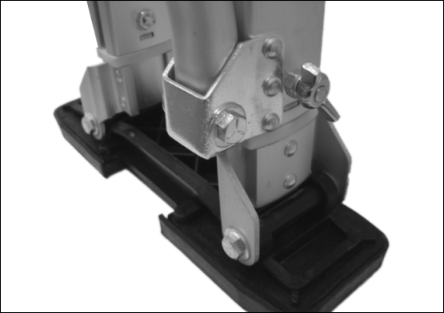

Strap Kit
1. Position the toe (short) and arch (long) straps on the footplates with the fasteners on the same side as the strut tube.
2. Feed the ends of both straps over and through the Safety Anchor Slot System and secure the straps with the strap plate & screws provided.
3. Set spring adjusters to minimum compression. Set adjustable stilt legs to the lowest setting and tighten wing bolts.
4. Re-check all the components you have assembled. Reposition the tube clamps and leg bands until you feel totally comfortable. You should stand straight on your stilts so the stilts don’t pull in or out.
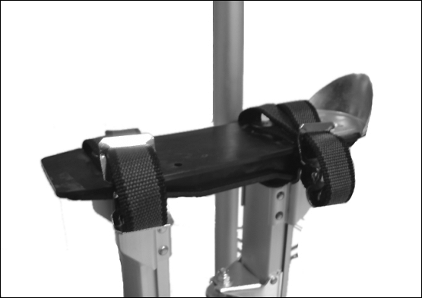

Height Adjustment
When adjusting the heights of the stilts remove wing bolts. Once removed evenly raise the stilt legs to the desired height. Once height is achieved re-align the wing bolt holes in legs and extension tubes replace the bolts and tighten well. Be sure not to over tighten as this can have adverse effect.

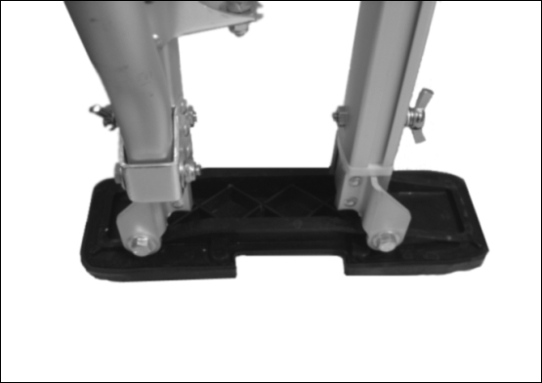
Wing bolts for height adjustment.

Maintainance of Stilts
Lubrication
In order to keep your stilts operating freely, it is necessary to keep the components reasonably clean and free of dents or burrs. Pay special attention to the components which help operate the movement. Lubricate these moving components lightly with a silicone spray or white graphite powder. Do not use lubricating products which remain wet and attract grit or any type of chemical cleaner. Make certain soles are kept free of lubricants which could cause loss of traction.

WARNING:

Do not make modifications on parts. Always use genuine replacement parts. Contact dealer for more information.
Replacement Nylon Sleeves
Remove wing bolts and remove the upper foot plate (together with the extension tubes and floor plate). Pry the small sleeves from the extension tube upper ends, and remove. The large sleeves can now be removed. To reassemble, check extension tube holes for burrs, file smooth. Slide new large sleeves down over the extension tubes until the large sleeve tabs are aligned over the detents at the bottom of the extension tubes. Insert new small sleeves over the top of the extension tubes until it snaps past the upper locking tabs of the extension tubes. Carefully insert the extension tube units all the way into the stilt legs until the large sleeve tabs snap and lock into the stilt leg slots. Check stilt operation by adjusting stilts up and down. Replace wing bolts and tighten.

Operation Guidlines
Walking precautions
IMPORTANT-Always take short, deliberate, distinct steps and walk with your stilts well apart. Large or over-extended steps can cause the action springs to bottom out and place excess stresses on the stilt components. Excess stresses could drastically reduce the life of the stilts or result in component breakage.
Inspect before working
Develop a habit of inspecting your stilts before each days use. Make certain the entire stilts are free of any sign of damage or excessive wear, and that all nuts and bolts are tight. Special attention should be given to the entire strut tube assemblies and wing bolts in this respect. Keep all labels legible.

Strap tightening sequence
Important-When mounting your stilts, always attach leg straps first before feet. When dismounting always unbuckle leg straps last, after unbuckling foot straps.Select a clear and level area away from doors, floor vents, stairwells, windows, etc. With the help of a colleague, strap on your stilts as noted above.Stand with your legs comfortably apart, collect your balance...and relax. If needed, re-adjust the strut tubes and clamps until your stilts and legs are straight and comfortable.

Forward/rearward balance
When standing erect, your stilts should be in a neutral and vertical position. If they have a tendency to lean forward or backward, make the following adjustments with the help of a colleague, or after removing your stilts.If stilts lean forward, loosen the tube clamps and rotate the leg bands and strut tubes toward the rear, and tighten clamps. This adjustment is to insure proper forward and backward balance. If this adjustment requires that the leg bands be rotated to where it is uncomfortable, the mounted shoes should be relocated, or the heel brackets be adjusted in the same direction as the needed rotation. Note: Do not bend or "size" leg bands.

Learning to Walk
IMPORTANT - Read the do's and don'ts for the use of your stilts before you attempt to learn to walk on them. Remember, in order to develop safe work habits, it is very important that you observe the do's and don'ts as you learn to walk on and work with them.Select a clear and level area (preferably near a wall) but away from doors, floor vents, stairwells, windows, etc. With the help of a colleague, mount your stilts and take slow deliberate short steps while keeping your stilts well apart. Make certain that each step completely clears the floor, as you must never drag or shuffle your feet. While assisted, walk slowly back and forth numerous times making a U-turn to reverse your direction. Repeat walking back and forth until you develop a "feel" for the stilts. Practice walking until you feel secure and are able to walk unassisted.

ADJUSTMENT FOR WALK
If you have a tendency to lean forward or backward while walking, you should adjust the action springs. Make the following adjustments after removing your stilts. To correct for leaning forward while walking, tighten the upper spring adjuster. To correct for leaning backward while walking, tighten the lower spring adjuster.
Never tighten adjusters more than 1/5 of the way down, or approximately 15 turns, as it will limit the stilt action and impose excess stresses on the components.

